12. Appendix A

12.1 Supplementary tables
Table 21. The number of clinical Campylobacter PCR positive samples received in the clinical microbiology laboratory in Oxford, from April 2019 to December 2024.
Key: NT:not tested meaning samples were not included in this study.
Month | Year: 2019 | Year: 2020 | Year: 2021 | Year: 2022 | Year: 2023 | Year: 2024 | Total:
Jan | NT | 62 | 38 | 29 | 62 | 71 | 262
Feb | NT | 51 | 38 | 44 | 50 | 36 | 219
Mar | NT | 45 | 47 | 58 | 50 | 61 | 261
Apr | 54 | 26 | 68 | 68 | 48 | 72 | 336
May | 81 | 50 | 63 | 55 | 74 | 54 | 377
Jun | 92 | 63 | 133 | 70 | 74 | 117 | 549
Jul | 92 | 76 | NT | 65 | 78 | 79 | 390
Aug | 57 | 74 | NT | 51 | 74 | 82 | 338
Sep | 96 | 26 | NT | 48 | 57 | 69 | 296
Oct | 56 | 64 | 52 | 45 | 72 | 57 | 346
Nov | 67 | 41 | 70 | 50 | 39 | 74 | 341
Dec | 52 | 53 | 40 | 34 | 59 | 65 | 303
Total | 647 | 631 | 549 | 617 | 737 | 837 | 4018

Table 22. Percentage of Oxfordshire human disease C. jejuni isolates, predicted to be resistant to fluoroquinolones, tetracycline or both antimicrobials.
Year | Fluoroquinolone | Tetracycline | Both
2003 | 28.2 | 49.5 | 21.8
2004 | 25.3 | 31.8 | 15.7
2006 | 37.7 | 35.8 | 23.6
2007 | 31.9 | 34.5 | 17.5
2009 | 32.0 | 43.0 | 26.6
2010 | 35.7 | 37.5 | 23.3
2011 | 39.7 | 39.2 | 26.4
2012 | 38.9 | 42.3 | 27.7
2013 | 39.6 | 42.0 | 28.8
2014 | 46.4 | 42.1 | 32.5
2015 | 43.4 | 40.8 | 30.3
2016 | 46.9 | 40.0 | 31.0
2017 | 41.1 | 38.1 | 29.2
2018 | 47.0 | 50.1 | 37.5
2019 | 45.8 | 37.5 | 28.2
2020 | 46.6 | 39.0 | 28.0
2021 | 55.9 | 44.6 | 37.5
2022 | 54.5 | 40.9 | 35.9
2023 | 55.1 | 34.6 | 32.1
2024 | 55.2 | 48.2 | 42.5

Table 23. Percentage of Oxfordshire human disease C. coli isolates, predicted to be resistant to fluoroquinolones, tetracycline or both antimicrobials.
Year | Fluoroquinolone | Tetracycline | Both
2003 | 44.4 | 50 | 33.3
2004 | 38.5 | 23.1 | 23.1
2006 | 23.1 | 23.1 | 15.4
2007 | 32.6 | 48.8 | 23.3
2009 | 66.7 | 66.7 | 66.7
2010 | 44.7 | 33.3 | 20.0
2011 | 33.3 | 36.8 | 18.4
2012 | 40.9 | 28.4 | 18.2
2013 | 38.7 | 26.4 | 18.9
2014 | 45 | 36 | 24
2015 | 31.3 | 38.1 | 20.6
2016 | 42.9 | 45.9 | 40.5
2017 | 37.9 | 29.3 | 22.4
2018 | 31.8 | 34.1 | 20.5
2019 | 42.1 | 21.3 | 13
2020 | 15.6 | 16.7 | 4.2
2021 | 45.2 | 23.1 | 23.1
2022 | 29.4 | 26.9 | 15.4
2023 | 16.2 | 31.3 | 18.8
2024 | 41.3 | 35.6 | 22.7

Table 24. The association of fluoroquinolone resistance with clonal complex, for Oxfordshire human disease isolates, 2019-2024.
Significant association with resistance/sensitivity (p < 0.01) chi square test or Fisher’s exact test for values <5. Clonal complexes with 10 or fewer isolates were omitted from the analysis.
Species | Clonal complex | Sensitive (n) | Sensitive (%) | Resistant (n) | Resistant (%) | Total | p value
C. jejuni | ST-21CC | 248 | 40.3 | 368 | 59.7 | 616 | <0.0001
C. jejuni | ST-22CC | 58 | 93.5 | 4 | 6.5 | 62 | <0.0001
C. jejuni | ST-42CC | 34 | 82.9 | 7 | 82.9 | 41 | <0.0001
C. jejuni | ST-45CC | 148 | 96.1 | 6 | 3.9 | 154 | <0.0001
C. jejuni | ST-48CC | 150 | 89.9 | 17 | 10.2 | 167 | <0.0001
C. jejuni | ST-49CC | 16 | 76.2 | 5 | 23.8 | 21 | 0.16
C. jejuni | ST-52CC | 21 | 31.8 | 45 | 68.2 | 66 | 0.0026
C. jejuni | ST-61CC | 33 | 94.3 | 2 | 5.7 | 35 | <0.0001
C. jejuni | ST-206CC | 77 | 65.8 | 40 | 34.2 | 117 | <0.0001
C. jejuni | ST-257CC | 58 | 77.3 | 17 | 22.7 | 75 | <0.0001
C. jejuni | ST-283CC | 24 | 100.00 | 0 | 0.00 | 24 | <0.0001
C. jejuni | ST-353CC | 15 | 8.7 | 158 | 91.3 | 173 | <0.0001
C. jejuni | ST-354CC | 2 | 4.3 | 45 | 95.7 | 47 | <0.0001
C. jejuni | ST-403CC | 31 | 63.3 | 18 | 36.7 | 49 | 0.06
C. jejuni | ST-443CC | 42 | 82.4 | 9 | 17.6 | 51 | <0.0001
C. jejuni | ST-464CC | 4 | 2.0 | 195 | 98.0 | 199 | <0.0001
C. jejuni | ST-508CC | 18 | 100.00 | 0 | 0.00 | 18 | <0.0001
C. jejuni | ST-658CC | 20 | 87.0 | 3 | 13.0 | 23 | <0.0001
C. jejuni | Unassigned | 41 | 17.9 | 188 | 82.1 | 229 | <0.0001
C. coli | ST-828CC | 170 | 66.7 | 85 | 33.3 | 255 | <0.0001
C. coli | Unassigned | 15 | 62.5 | 9 | 0.4 | 24 | 0.22
Total | All | 1225 | 50.1 | 1221 | 49.9 | 2446

Table 25. The association of tetracycline resistance with clonal complex, for Oxfordshire human disease isolates, 2019-2023.
Significant association with resistance/sensitivity (p < 0.01) chi square test or Fisher’s exact test for values <5. Clonal complexes with 10 or fewer isolates were omitted from the analysis.
Species | Clonal complex | Sensitive (n) | Sensitive (%) | Resistant (n) | Resistant (%) | Total | p value
C. jejuni | ST-21CC | 378 | 60.19 | 250 | 39.81 | 628 | 0.0196
C. jejuni | ST-22CC | 62 | 98.41 | 1 | 1.59 | 63 | <0.0001
C. jejuni | ST-42CC | 34 | 80.95 | 8 | 19.05 | 42 | <0.0001
C. jejuni | ST-45CC | 154 | 96.86 | 5 | 3.14 | 159 | <0.0001
C. jejuni | ST-48CC | 105 | 62.50 | 63 | 37.50 | 168 | 0.0880
C. jejuni | ST-49CC | 21 | 95.45 | 1 | 4.55 | 22 | <0.0001
C. jejuni | ST-52CC | 30 | 44.12 | 38 | 55.88 | 68 | 0.0419
C. jejuni | ST-61CC | 35 | 97.22 | 1 | 2.78 | 36 | <0.0001
C. jejuni | ST-206CC | 58 | 48.33 | 62 | 51.67 | 120 | 0.0753
C. jejuni | ST-257CC | 57 | 74.03 | 20 | 25.97 | 77 | 0.0014
C. jejuni | ST-283CC | 25 | 100 | 0 | 0.00 | 25 | <0.0001
C. jejuni | ST-353CC | 20 | 11.56 | 153 | 88.44 | 173 | <0.0001
C. jejuni | ST-354CC | 1 | 0.00 | 46 | 100 | 47 | <0.0001
C. jejuni | ST-403CC | 41 | 82.0 | 9 | 18.0 | 50 | 0.0002
C. jejuni | ST-443CC | 27 | 50.94 | 26 | 49.06 | 53 | 0.4363
C. jejuni | ST-464CC | 5 | 2.49 | 196 | 97.51 | 201 | <0.0001
C. jejuni | ST-508CC | 18 | 100 | 0 | 0.00 | 18 | <0.0001
C. jejuni | ST-658CC | 18 | 78.26 | 5 | 21.74 | 23 | 0.0321
C. jejuni | Unassigned | 116 | 50.22 | 115 | 49.78 | 231 | 0.0546
C. coli | ST-828CC | 178 | 66.67 | 89 | 33.33 | 267 | 0.0002
C. coli | Unassigned | 19 | 79.17 | 2 | 20.83 | 24 | 0.0226
Total | All | 1402 | 56.19 | 1093 | 43.81 | 2495

Table 26. The association of fluoroquinolone resistance with clonal complex, AgriFood and environmental isolates.
Species | Clonal complex | Sensitive (n) | Sensitive (%) | Resistant (n) | Resistant (%) | Total | p value
C. jejuni | ST-21CC | 76 | 49.03 | 79 | 50.97 | 155 | <0.001
C. jejuni | ST-42CC | 79 | 100 | 0 | 0 | 79 | <0.001
C. jejuni | ST-45CC | 60 | 100 | 0 | 0 | 60 | <0.001
C. jejuni | ST-48CC | 20 | 100 | 0 | 0 | 20 | 0.096
C. jejuni | ST-49CC | 12 | 100 | 0 | 0 | 12 | 0.3889
C. jejuni | ST-61CC | 24 | 100 | 0 | 0 | 24 | 0.064
C. jejuni | ST-177CC | 12 | 100 | 0 | 0 | 12 | 0.3889
C. jejuni | ST-353CC | 3 | 23.08 | 10 | 76.92 | 13 | <0.001
C. jejuni | ST-354CC | 9 | 81.81 | 2 | 18.18 | 11 | 0.65
C. jejuni | ST-443CC | 78 | 100 | 0 | 0 | 78 | <0.001
C. jejuni | ST-464CC | 0 | 0 | 12 | 100 | 12 | <0.001
C. jejuni | ST-573CC | 34 | 91.89 | 3 | 8.11 | 37 | 0.47
C. jejuni | ST-574CC | 1 | 6.67 | 14 | 93.33 | 15 | <0.001
C. jejuni | ST-607CC | 49 | 98 | 1 | 2 | 50 | 0.01
C. jejuni | ST-658CC | 15 | 100 | 0 | 0 | 15 | 0.246
C. jejuni | ST-661CC | 39 | 100 | 0 | 0 | 39 | 0.007
C. jejuni | ST-692CC | 28 | 100 | 0 | 0 | 28 | 0.0248
C. jejuni | ST-702CC | 13 | 100 | 0 | 0 | 13 | 0.2358
C. jejuni | ST-1034CC | 35 | 100 | 0 | 0 | 35 | 0.0103
C. jejuni | ST-1287CC | 18 | 100 | 0 | 0 | 18 | 0.157
C. jejuni | Unassigned | 103 | 88.79 | 13 | 11.21 | 116 | 0.42
C. coli | ST-828CC | 287 | 85.16 | 50 | 14.84 | 337 | 0.48
C. coli | ST-1150CC | 100 | 100 | 0 | 0 | 100 | <0.001
C. coli | Unassigned | 78 | 93.98 | 5 | 6.02 | 83 | 0.04

Table 27. The association of tetracycline resistance with clonal complex, AgriFood and environmental isolates.
Species | Clonal complex | Sensitive (n) | Sensitive (%) | Resistant (n) | Resistant (%) | Total | p value
C. jejuni | ST-21CC | 155 | 100 | 0 | 0 | 155 | <0.001
C. jejuni | ST-42CC | 79 | 100 | 0 | 0 | 79 | <0.001
C. jejuni | ST-45CC | 56 | 100 | 4 | 0 | 60 | <0.001
C. jejuni | ST-48CC | 20 | 93.33 | 0 | 6.67 | 20 | <0.001
C. jejuni | ST-49CC | 12 | 100 | 0 | 0 | 12 | 0.0055
C. jejuni | ST-61CC | 24 | 100 | 0 | 0 | 24 | <0.001
C. jejuni | ST-177CC | 12 | 100 | 0 | 0 | 12 | 0.0055
C. jejuni | ST-206CC | 8 | 100 | 0 | 0 | 8 | 0.0569
C. jejuni | ST-353CC | 7 | 53.85 | 6 | 46.15 | 13 | 0.564
C. jejuni | ST-354CC | 9 | 81.81 | 2 | 18.18 | 11 | 0.3572
C. jejuni | ST-443CC | 10 | 12.82 | 68 | 87.18 | 78 | <0.001
C. jejuni | ST-464CC | 0 | 0 | 12 | 100 | 12 | <0.001
C. jejuni | ST-573CC | 8 | 21.62 | 29 | 78.38 | 37 | <0.001
C. jejuni | ST-574CC | 0 | 0 | 15 | 100 | 15 | <0.001
C. jejuni | ST-607CC | 2 | 4 | 48 | 96 | 50 | <0.001
C. jejuni | ST-658CC | 15 | 100 | 0 | 0 | 15 | 0.0018
C. jejuni | ST-661CC | 1 | 2.56 | 38 | 97.44 | 39 | <0.001
C. jejuni | ST-692CC | 7 | 25 | 21 | 75 | 28 | <0.001
C. jejuni | ST-702CC | 13 | 100 | 0 | 0 | 13 | 0.0032
C. jejuni | ST-1034CC | 31 | 88.57 | 4 | 11.43 | 35 | 0.0018
C. jejuni | ST-1287CC | 18 | 100 | 0 | 0 | 18 | <0.001
C. jejuni | Unassigned | 101 | 87.07 | 15 | 12.93 | 116 | <0.001
C. coli | ST-828CC | 209 | 62.02 | 128 | 37.98 | 337 | 0.4667
C. coli | ST-1150CC | 4 | 4 | 96 | 96 | 100 | <0.001
C. coli | Unassigned | 72 | 86.75 | 11 | 13.25 | 83 | <0.001

Table 28. Frequency of isolates with variant REcmeABC promotor region from UK human disease and AgriFood isolates.
Key: gyrA:T86I fluoroquinolone resistant; gyrA:T86- fluoroquinolone sensitive *identified in this study
Id | Inverter repeat sequence | Inverter repeat mutation | ^{pro}CAMP0332 allele | Clonal complexes | gyrA:  T86I | gyrA: T86- | gyrA: No data | Source | Year
#1 | TGTAATAAAAATTATA⁹⁴ | 2 point mutations | Allele 7 | ST-21CC,  ST-206CC,  ST-353CC,  ST-464CC,  ST-607 | 129 |  | 3 | Human | 2019, 2021, 2024
#2 | TGTAATAAA-ATTACA* | Indel | Allele 9,  Allele 38 | ST-21CC,  ST-49CC,  ST-61CC,  ST-353CC,  ST-443CC  ST-453CC  U/A C. jejuni | 75 | 1 | 1 | Human, chicken, starling | 2004, 2019,  2021,  2022, 2023, 2024
#3 | TATAATAAAAATTACA⁹⁴ | 2 point mutations | Allele 12, Allele 39 | ST-21CC  ST-206CC  ST-257CC  ST-353CC  U/A C. jejuni | 8 | 4 |  | Human | 2012, 2019, 2023, 2024
#4 | TGTAATAAATATTACTATTACA⁹⁴ | Indel | Allele 14,  Allele 19,  Allele 48 | ST-21CC  ST-48CC  ST-353CC  ST-446CC  U/A C. jejuni | 16 | 3 |  | Human, Chicken | 2007, 2019, 2020, 2021, 2022, 2023, 2024
#5 | TATAATAAATATTACA⁹⁴ | 1 point mutation | Allele 18, Allele 28, Allele 58 | ST-353CC, ST-464CC, ST-607CC, ST-828CC | 29 |  | 1 | Human | 2020, 2019, 2023, 2024
#6 | TGTAATAAAAAATTACA* | Indel | Allele 22 | ST-21 complex | 1 |  |  | Human | 2019
#7 | TGTAATAAATATTATA⁹⁴ | 1 point mutation | Allele 23, Allele 30 | ST-353CC, ST-574CC, U/A C. jejuni | 9 |  |  | Human | 2019, 2020, 2022, 2023, 2024
#8 | TGTAATAA-TATTACA¹⁷ | 1 point mutation | Allele 25 | ST-354CC | 1 |  |  | Human | 2020
#9 | CGTAATAAATATTACA* | 1 point mutation | Allele 31 | ST-403CC | 2 |  |  | Human | 2019, 2020
#10 | TGTAATAGATATTACA* | 1 point mutation | Allele 33 | ST-952CC, U/A C. jejuni | 2 |  |  | Human | 2021, 2023
#11 | TGTAATAAAT-TTACA* | 1 point mutation | Allele 34 | ST-446CC | 1 |  |  | Human | 2019
#12 | TGTAATAAATATTGCA* | 1 point mutation | Allele 37,  Allele 40 | ST-45CC  ST-828CC | 2 |  |  | Human | 2020, 2021
#13 | TGTATAATAAATATTACA* | Indel | Allele 51,  Allele 63 | ST-828CC | 2 |  |  | Human Chicken | 2014, 2023
#14 | TGTAATAAAA-TTACA* | Indel | Allele 59, Allele 60 | U/A C. jejuni, U/A C. coli | 2 |  |  | Human | 2024
#15 | TGTAATAAATAATTACA* | Indel | Allele 62 | ST-1034CC, U/A C. jejuni | 12 |  |  | Goose | 2022, 2023

Table 29. Campylobacter isolates included in the aerotolerance phenotyping pilot study.
*ST-45 complex is recognised to be multi-host associated but is annotated as environmental for the purposes of this study to reflect its frequent isolation from wild birds and water sources. Key: wild type = fluoroquinolone sensitive; ‘-‘ = no tetracycline/macrolide resistance determinants detected.

Clonal complex | Host association | FQ resistance | Tetracycline resistance | Macrolide resistance | <24 hour survival (frequency) | 24 hour survival (frequency) | 48 hour survival (frequency) | 72 hour survival (frequency) | 96 hour survival (frequency) | Total
ST-21CC | Multi-host | T86I | - | - |  | 3 | 2 |  |  | 5
ST-21CC | Multi-host | T86I | tet(O) | - |  | 5 | 1 |  |  | 6
ST-21CC | Multi-host | Wild type | - | - |  | 4 |  | 1 |  | 5
ST-45CC* | Environment | T86I | - | - | 1 | 7 |  |  |  | 8
ST-45CC* | Environment | T86I | tet(O) | - | 1 |  |  |  |  | 1
ST-45CC* | Environment | Wild type | - | - |  | 1 |  |  |  | 1
ST-48CC | Chicken | T86I | - | - |  | 5 |  |  |  | 5
ST-48CC | Chicken | T86I | tet(O) | - |  | 2 | 1 | 1 |  | 4
ST-48CC | Chicken | Wild type | tet(O) | - |  | 1 |  |  |  | 1
ST-48CC | Chicken | Wild type | - | - |  |  | 1 |  |  | 1
ST-206CC | Chicken | D90N | tet(O) | - |  |  | 1 |  |  | 1
ST-257CC | Chicken | T86I | - | - |  | 1 |  |  |  | 1
ST-257CC | Chicken | T86I | tet(O) | - |  | 6 | 2 |  |  | 8
ST-353CC | Chicken | T86I | - | - |  | 1 |  |  |  | 1
ST-353CC | Chicken | T86I | tet(O) | - |  | 5 | 4 |  |  | 9
ST-353CC | Chicken | Wild type | - | - |  | 2 | 4 |  |  | 6
ST-354CC | Chicken | T86I | - | - |  | 7 | 1 |  | 1 | 9
ST-354CC | Chicken | T86I | tet(O) | A2075G |  |  | 1 |  |  | 1
ST-354CC | Chicken | Wild type | tet(O) | - |  |  |  |  | 1 | 1
ST-354CC | Chicken | Wild type | - | - |  | 2 | 2 |  |  | 4
ST-403CC | Cattle/Pigs | T86I | - | - |  | 1 |  |  |  | 1
ST-403CC | Cattle/Pigs | T86I | - | A2075G |  | 2 |  |  |  | 2
ST-464CC | Chicken | T86I | tet(O) | - |  | 6 | 3 |  |  | 9
ST-574CC | Chicken | T86I | - | - |  |  | 1 |  |  | 1
ST-574CC | Chicken | T86I | tet(O) | A2075G |  | 1 |  |  |  | 1
ST-574CC | Chicken | Wild type | tet(O) | - |  | 3 | 4 |  |  | 7
ST-1034CC | Environment | Wild type | tet(O) | - | 1 | 1 | 1 |  |  | 3
ST-1034CC | Environment | Wild type | - | - | 2 |  |  |  |  | 2
U/A C. jejuni | Unassigned | P104S | - | - |  | 2 | 1 | 2 |  | 5
U/A C. jejuni | Unassigned | T86I | tet(O) | A2074G |  | 2 |  |  |  | 2
U/A C. jejuni | Unassigned | T86I | - | A2075G |  | 1 |  |  |  | 1
ST-828CC | C. coli | T86I | - | - |  |  | 1 |  | 2 | 3
ST-828CC | C. coli | T86I | tet(O) | - |  |  |  | 2 | 4 | 6
ST-828CC | C. coli | T86I | tet(O) | A2075G |  |  |  |  | 1 | 1
ST-828CC | C. coli | Wild type | tet(O) | - |  |  | 2 |  |  | 2
ST-828CC | C. coli | Wild type | - | - |  |  | 2 | 1 | 1 | 4
U/A C. coli | C. coli | T86I | tet(O) | A2075G |  |  |  | 1 |  | 1
U/A C. coli | C. coli | Wild type | - | - |  |  | 1 |  |  | 1

13. Appendix B

13.1 Assembly statistics
Figure 33. The number of contigs for the isolate sequence assemblies.

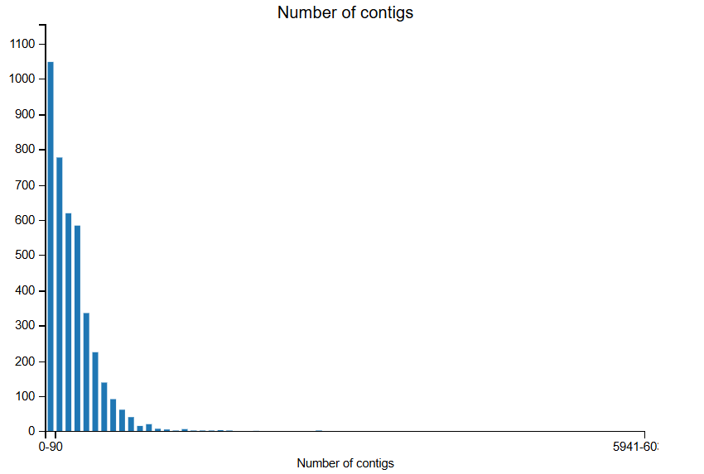

Figure 34. The mean contig length for the isolate sequence assemblies.
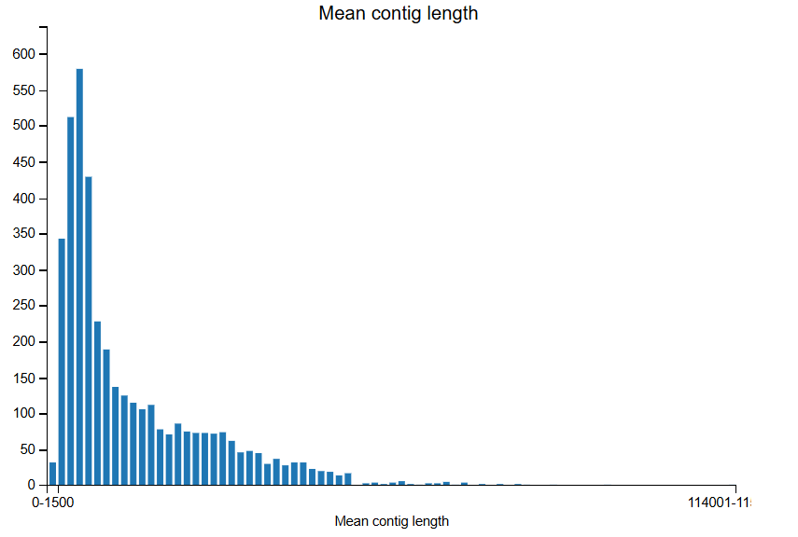

Table 30. Assembly statistics for the entire data set.
 | N₅₀ length (bp) | Contigs (n) | Total length (Mb)
Mean | 29532 | 239 | 1452808
Std Deviation | 46883 | 289 | 183123
Minimum | 1285 | 15 | 1478522
25% | 8752 | 85 | 1649884
50% | 16783 | 208 | 1700686
75% | 59523 | 355 | 1746781
Maximum | 436455 | 5960 | 6935133

13.2 Glossary
Antimicrobial stewardship: a co-ordinated approach to promote optimal use of antimicrobials
AMR: Antimicrobial resistance
BIGSdb: Bacterial Isolate Genome Sequence Database
CC: clonal complex
cgMLST: core genome multilocus sequencing typing
cgST: core genome sequence type
ECOFF: Epidemiological cut-off for antimicrobial resistance phenotyping
GBS: Guillain Barré Syndrome
IBS: Irritable Bowel Syndrome
mCCDA: modified charcoal cefoperazone deoxycholate agar.
MLST: mulitlocus sequence typing
One Health: a unified approach recognising that the health of humans, animals (domestic and wild), plants the wider environment/ecosystems are closely linked and interdependent (WHO definition)
PCR: Polymerase chain reaction.
RE cmeABC: Resistance enhancing cmeABC efflux pump
ReA: Reactive Arthritis
ST: sequence type
SNP: single nucleotide polymorphism
wgMLST; whole genome multilocus sequence typing
WGS: whole genome sequencing
WHO: World Health Organisation

