A survey of microbiological and antimicrobial resistance (AMR) contamination found in raw dog and cat food on retail sale in the UK
FSA Project FS900253
Annex: Pack weight and cost in relation to E. coli counts and presence of Salmonella spp.
frieda.jorgensen@ukhsa.gov.uk

Pack weight and cost data
The average pack weight of the raw pet food samples was 0.94 kg (Table 1) with a minimum weight of 0.1 and maximum of 10 kg; the 1st, 2nd, 3rd and 4th quartiles were 0.45, 0.5, 1 and 10 kg, respectively (Table 1).
Table 1. Pack weight data from raw dog and cat food samples.
Pack weight descriptor | kg
Average | 0.94
Median | 0.50
Minimum | 0.10
Maximum | 10.00
Quartile 1 | 0.45
Quartile 2 | 0.50
Quartile 3 | 1.00
Quartile 4 | 10.00

The average cost per kg of the raw pet food samples was 12.03 £ per kg (Table 2) with the lowest cost of 2 £ per kg and the highest cost of 100 £ per kg. The 1st, 2nd, 3rd and 4th quartiles were 4.80, 6.70, 14.60 and 100 £ per kg, respectively (Table 2) meaning 95 samples were priced at 2.4 to 4.7 £ per kg, 95 samples at 4.8 to 6.6 £ per kg, 95 samples at 6.7 to 14.6 £ per kg and finally 95 samples at 14.7 to 100 £ per kg.
Table 2. Cost of raw dog and cat food samples.
Cost descriptor | Cost per kg
Average | 12.03
Median | 6.70
Minimum | 2.00
Maximum | 100.00
Quartile 1 | 4.8
Quartile 2 | 6.7
Quartile 3 | 14.6
Quartile 4 | 100.0

Pack weight in relation to counts (CFU/g) of indicator E. coli

The likelihood of samples with above average pack weights containing > 5000 E. coli CFU/g was not significantly different compared to samples with pack weights of 0.94 kg or less (chi-square; p = 0.48).
An illustration of indicator E. coli counts by pack weight of raw pet food samples is shown in Figure 1.
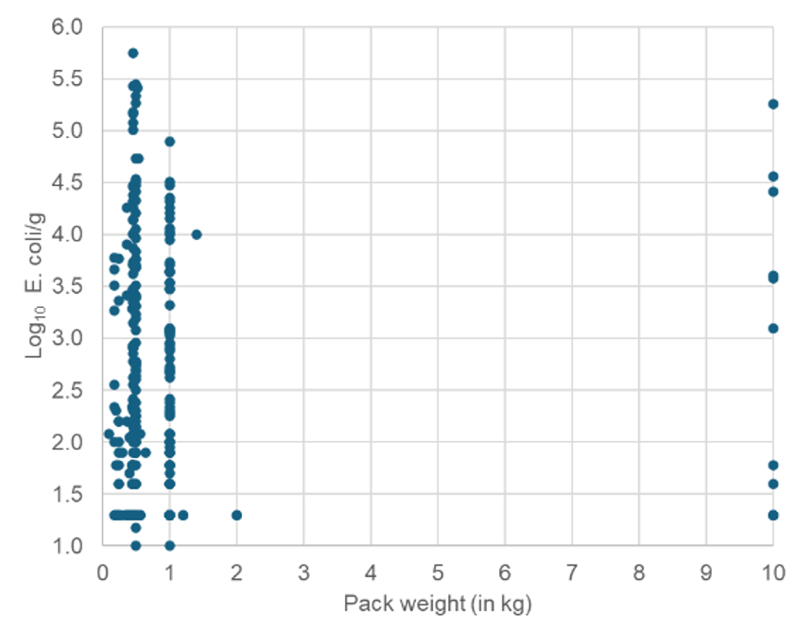
Figure 2. E. coli counts in raw pet food samples by pack weight of samples with E. coli counts >5000 CFU/g above the green line.

Cost of raw pet food in relation to counts (CFU/g) of indicator E. coli
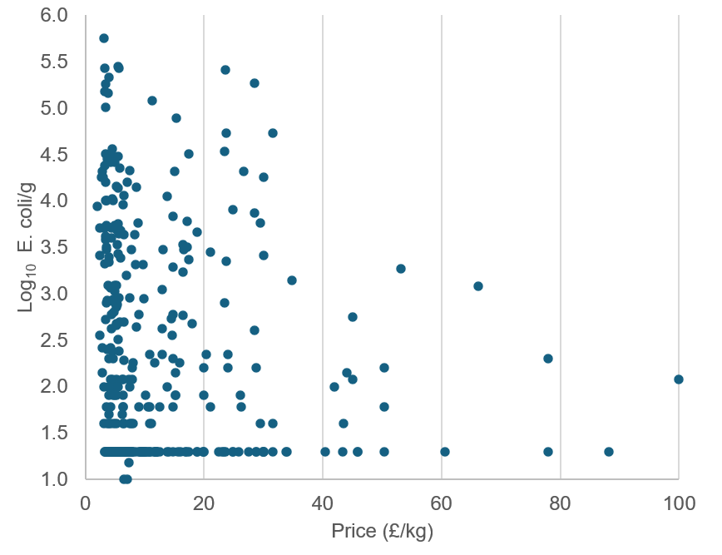
Figure 2. E. coli counts in raw pet food samples by cost of samples with E. coli counts >5000 CFU/g above the green line.
The likelihood of samples containing more than 5000 CFU of E. coli per g was not significantly different between samples costing more than the average of £ 12.03 per kg compared to those costing £ 12.03 or less per kg (chi-square; p = 0.71).
The counts of indicator E. coli by cost of samples (calculated as £ per kg) is illustrated in Figure 2.

Pack weight of raw pet food samples in relation to detection of Salmonella spp.
Salmonella was detected in a significantly higher proportion (35%) of samples weighing above the average (0.94 kg) pack weight compared to samples (11%) with pack weights of 0.94 kg or less (chi-square; p < 0.001). The reason for the increased probability of detecting Salmonella in samples with higher pack weights could not be investigated further with the available data. It is possible it may relate to brand as at least all 10 kg samples were of the same brand. Other factors such as a possibility of larger packs containing material from a greater number of individual animals may also increase the likelihood of contamination with Salmonella. While these explanations cannot be verified with the current dataset, they represent plausible contributing factors and warrant consideration. Detection of Salmonella in relation to pack weight and counts of indicator E. coli is illustrated in Figure 3.

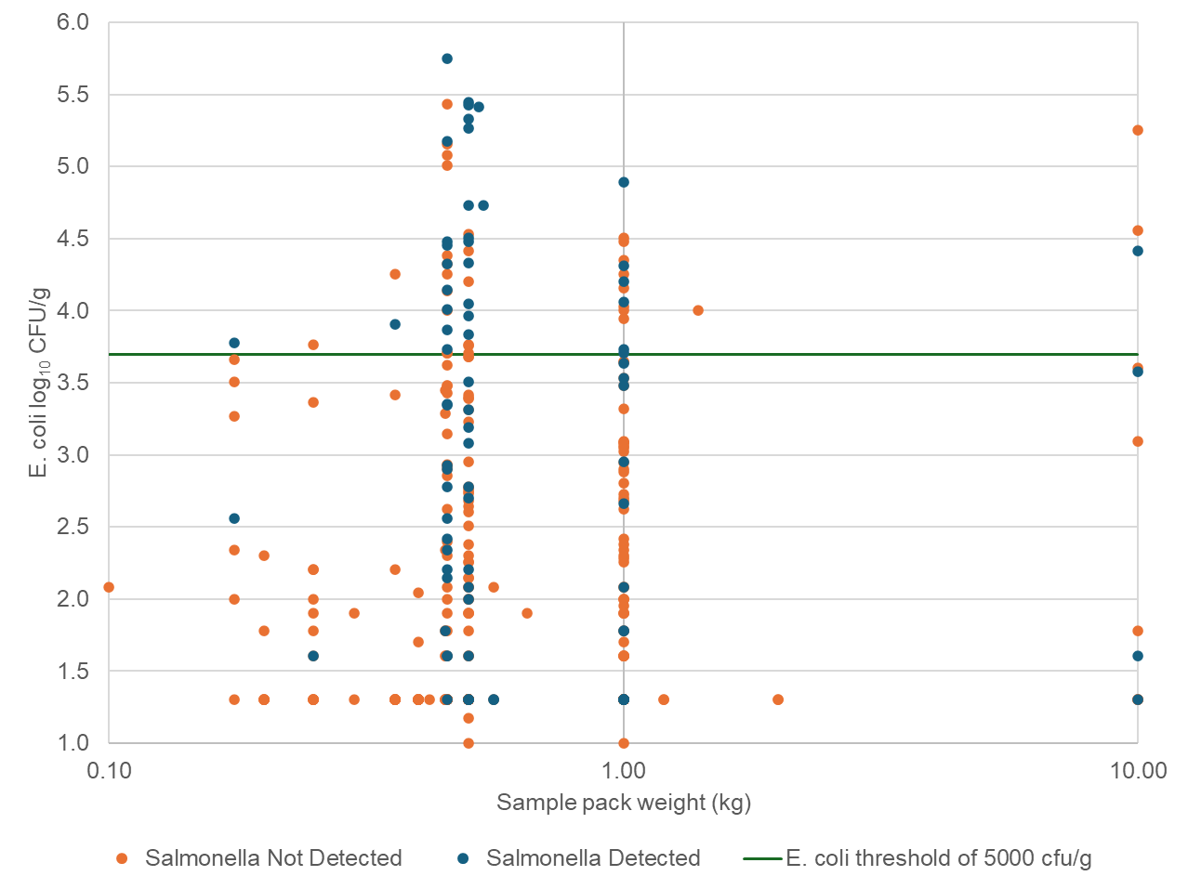
Figure 3. Detection of Salmonella spp. in raw pet food samples by counts of E. coli and sample pack weight.

Cost of raw pet food samples in relation to detection of Salmonella spp.
The likelihood of Salmonella detection was not significantly different between samples costing more than the average price of £12.03 per kg compared to those costing £12.03 or less (chi-square; p = 062).
Detection of Salmonella in relation to cost of samples and counts of indicator E. coli is illustrated in Figure 4.
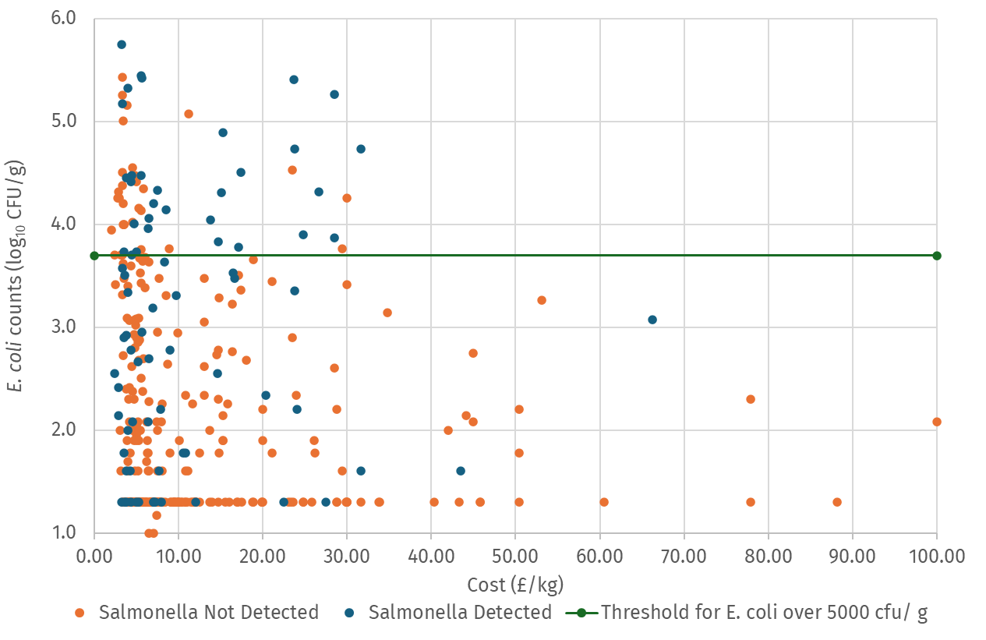
Figure 4. Detection of Salmonella spp. in raw pet food samples by counts of E. coli and cost of sample.
In conclusion the analysis of pack weight and cost in relation to presence of Salmonella spp. and level of E. coli counts demonstrated little effect of cost or pack weight, except for a moderate size effect of pack weight with detection of Salmonella being more probable in samples with higher pack weights.

