Appendix I – Methods supplementary material
Reads were trimmed using cutadapt 4.9 (parameters:--discard-untrimmed --cut 50 --cut -50 --revcomp --minimum-length 800 --maximum-length 1200 -g file:primer_sequences.fasta) [24]. Primers were specified as linked adaptors, with the minimum overlap and maximum error parameter being specified individually for each primer (Table MS1).
Table MS1: Primer sequences and the associated parameters used to detect ‘linked adaptors’ when running cutadapt.
Primer | Geno-group | Forward (F) /  Reverse (R) | Sequence | Minimum Overlap | Maximum Errors | Optional
NV4562m | GI | F | GATGCDGAYTAYACRGCHTGGG | 17 | 4 | Yes
GISKRm | GI | R | CCNACCCANCCATTRTACA | 15 | 3 | Yes
NV4692 | GII | F | GTGTGRTKGATGTGGGTGACTT | 17 | 4 | Yes
GIISKR | GII | R | CCRCCNGCATRHCCRTTRTACAT | 18 | 5 | Yes

NGSpeciesID 0.3.0 was used to cluster reads and form consensus sequences for each sample (parameters: --ont --consensus --max_seqs_for_consensus 10000 --rc_identity_threshold 0.8 --mapped_threshold 0.8 -m 1100 --s 200) [25]. The software was manually altered to skip the polishing stage using medaka, and to remove any consensus sequences supported by less than 100 reads.
KMA 1.4.15 was used to index consensus sequences from each sample (parameters: -NI). Trimmed reads were then aligned against consensus sequences (parameters: -sam 4 -vcf 1 -ConClave 1 -bcNano -bc 0.7 -bcd 100 -md 100 -1t1 -ont -ml 900 -xl 1100 -ef -mrs 0.92 -mrc 0.90) [26]. Alignment results were sorted and indexed using Samtools 1.21 [27, 28].
Clair3 1.0.8 was used to call variants using results from the KMA alignment as described elsewhere [29, 30]. Bedtools 2.31.1 was used to calculate coverage across each consensus sequence (parameters: genomecov -bga). AWK and other bash tools were used to lookup the overall number of reads aligning against each reference, and identify any regions where coverage fell below 75% of that value [31]. BCFtools 1.2 was used to polish consensus sequences using variants called by Clair3, and soft mask lower coverage regions of the consensus sequence (parameters: --include ‘GT=”hom”’ --mask-with lc) [28]. SeqKit 2.8.2 [32] and Bedtools [31] were used to identify and trim any soft masked regions at the end of each consensus.AWK and other bash tools were used to identify consensus sequences supported by more than 0.5% of trimmed reads, with Bedtool’s getfasta command being used to remove any sequences with poor support. Minimap 2.26 was used to carry out an all-vs-all alignment of consensus sequences from each sample (parameters: -x asm5 -X --cs -z 50) [33]. The results were parsed by a custom python script looking for cases where a potential chimera was partially aligned against other sequences of higher abundance, with the alignments starting within 30bp from each end and overlapping in the middle by 10 to 200bp. The potential chimeras were then removed from each sample using SeqTK 1.4 [34].
A single set of consensus sequences was collated from across every sample, renamed using SeqTK 1.4 and clustered using cd-hit 4.8.1 (parameters: -G 1 -c 0.98 -n 11 -d 0 -M 100000 -g 1 -p 1 -S 5) [35].
After removal of chimeric sequences, as well as polishing, trimming and clustering of the remaining sequences, KMA 1.4.15 was used to align reads from each sample against a single set of representative sequences (parameters: vcf 1 -ConClave 1 -bcNano -bc 0.7 -bcd 100 -md 100 -1t1 -ont -ef mrs 0.92 -mrc 0.90 -ml 900) [26].
To try and account for the possibility of ‘index hopping’ representative sequences supported by less than 2 percent of the median number of reads per a sample were removed from the results, with the calculation done separately for each library.

Filtering of chimeras and sequences with low support
The average percentage of reads per a sample removed due to being putative chimeras was low, with relatively little variation seen across each library (Table MS2).
Table MS2: The average and maximum percentage of chimeric reads per a sample identified and removed prior to tabulating the frequency of different genotypes
Library | Average percentage of chimeric reads per sample (%) | Maximum percentage of chimeric reads per sample (%)
PNV_1 | 1.08 | 10.27
PNV_2 | 0.62 | 4.41
PNV_3 | 1.17 | 9.15
PNV_4 | 1.46 | 5.16

The median percentage of reads per a sample removed due to being associated with poorly supported genotypes varied between 1.04 and 4.48%, though in the case of six samples, all of the reads were removed, due to having much lower sequencing depth than other samples and therefore thought to be more likely due to ‘index hopping’.

Cleaning up and checking for inconsistencies in the available metadata
The names provided for sampling locations included abbreviations, contractions, text written in upper and lower case, typos and labels with varying levels of geographical specificity, all of which therefore necessitated manually reading through the list of sites and rationalising them prior to doing any further analysis. Overall, the 102 different site names were mapped to 32 wastewater treatment facilities, after accounting for potential variations in name, checking sampling frequencies and comparing against information available online. The final list of sites was then verified by NHS Lothian team.
Two technical replicates, where the same site was sampled on the same date more than once, were noticed (Table MS3).
Table MS3. Technical replicates or duplicates included in the sequencing dataset.
Site | Date | Sample ID
Hatton | 2024-10-08 | XV000272A, XV000269R
Seafield | 2024-10-08 | XV000266J, XV000271W

Appendix II – Results supplementary material
Table S1 – List of the wastewater treatment plants participating in this study.
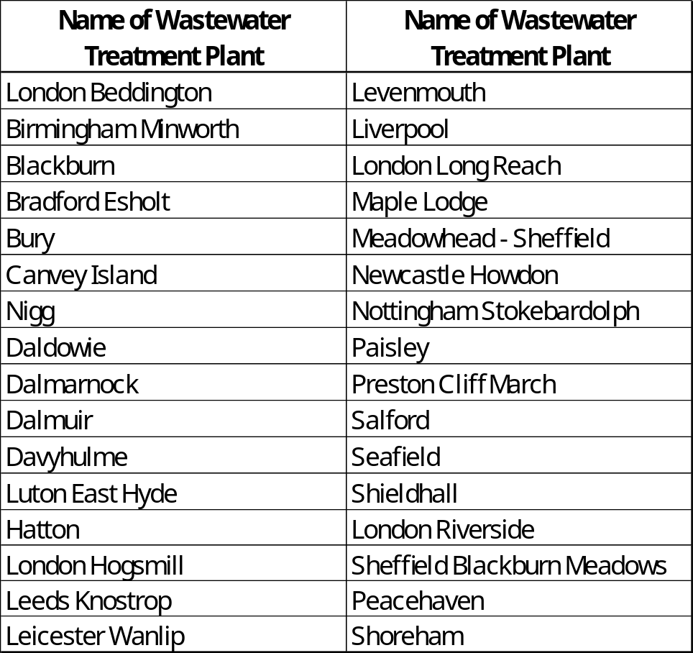

Table S2 - Number of consensus sequences (GI and GII) detected by site and collection date.
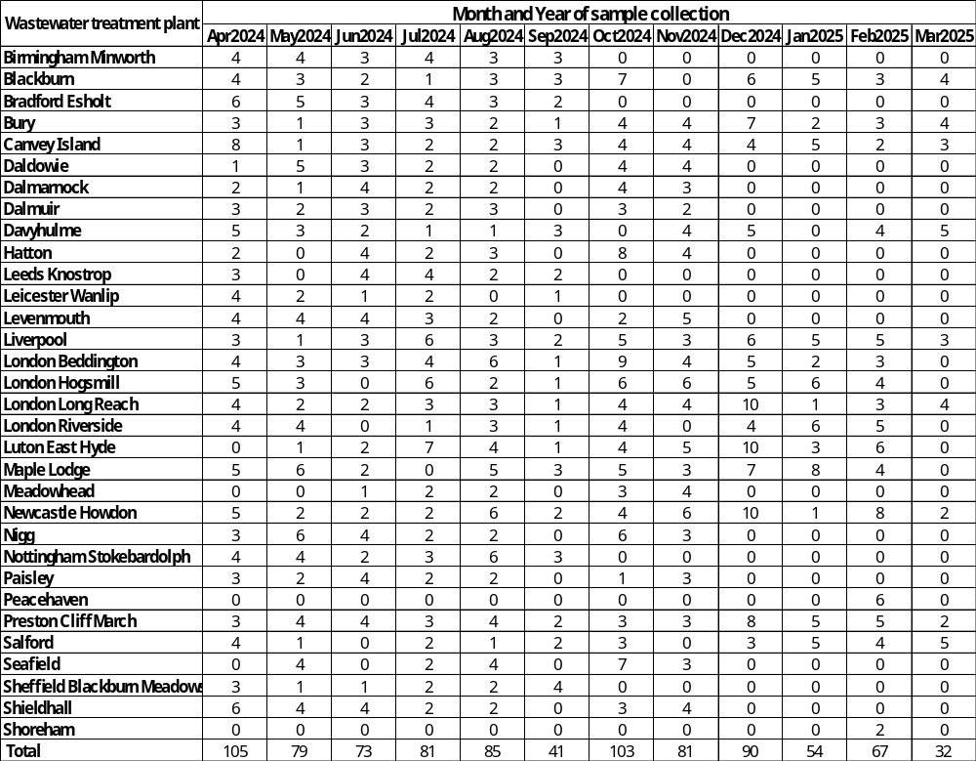
Table S3 – The number of positive sites by collection date and strain.
