PATH-SAFE:
Rapid in-field diagnostic technologies for foodborne pathogens
Annex 4: Training instructions for detection of E. coli in irrigation water.

NOTE: This document is a training aid for participants in the pilot study and is not intended to be used for testing without future revision to ensure consistent and safe implementation.
Anti-contamination practice.
- Clean surface with 70% alcohol solution/wipes before starting work.
- Only use one pipette tip per sample and change the tip if it comes into contact with any surface.
- Do not ‘pop’ tubes open but open carefully using both hands, only open one sample lid at a time and close immediately after use.
Important points
- Chemical reagents used can be hazardous – wear appropriate PPE including gloves and safety glasses.
Sample preparation
- Collect 100 ml water sample from surface in a sterile bottle and try to avoid any large debris or sediment.
- Allow a few minutes for any sediment to settle to the bottom to avoid clogging the filter.
- Set up the filtration apparatus by attaching the vacuum hand pump to the disposable filter funnel via the clear plastic tubing.
- Pour 100 ml of sample into the funnel by decanting and filter by compressing the hand vacuum pump a few times until water starts to flow through.
- Once the sample is filtered remove the funnel section to expose the filter paper.
- Prepare the homogenisation tube by unscrewing the capped tube and set the ball bearing in the inverted cap of the tube.
- Carefully fold the filter paper into a loose tube using disposable forceps or your hands – with the sample facing inwards and place the filter paper into 5 ml collection tube. If you used your hands changed gloves.
- Spread and flatten your filter against the inside of the tube.
- Using a 1 mL transfer pipette, add 2mL of the homogenization buffer (BLB) to the tube and add the ball bearing to the centre.
- Close the cap and vigorously shake the tube for 1 minute to mechanically disrupt the sample.

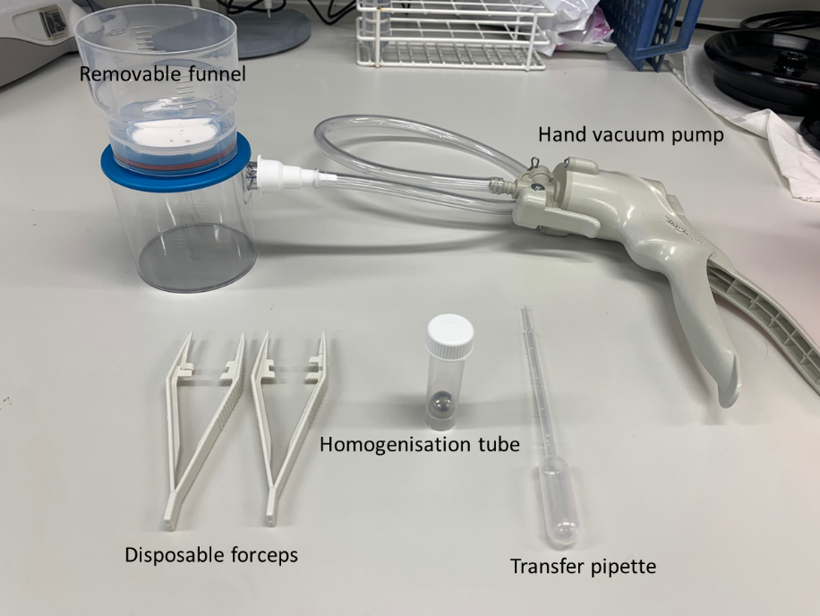
DNA extraction
Important points
- Make sure each well has a second puncture hole – apart from the air dry well.
- Pump the syringe at a natural tempo; follow the speed of the liquid (except the air dry, which should always be pumped rapidly).
- Move sequentially through the cartridge.
- Make sure all liquid is expelled from the syringe before moving to the next well.

- Using a 1 ml syringe, draw up to 1 ml of the homogenized solution containing your sample.
- Firmly seat the syringe tip onto the syringe luer lock. Use the tip of the syringe to puncture two holes into the foil covering on the first well of the cartridge -one for adding the sample and one for air flow. Note: To avoid contamination, do not touch the syringe tip on any other surface.
- Slowly push down on the syringe plunger to add your sample into well 1 of sample prep cartridge. This is the step where DNA is bound to the silica within the syringe tip.
- Hold the syringe by the column with one hand while pumping with the other.
- Draw the sample in and out of the pipette for the specified number of times for each well. The specified number of times for drawing the sample in and out of the syringe is depicted on the side of the cartridge for reference.
- In the final well the DNA is being released from the silica and back into the liquid. Therefore, at the end of this step draw all the liquid into the syringe and move to a 1.5 ml labelled collection tube.

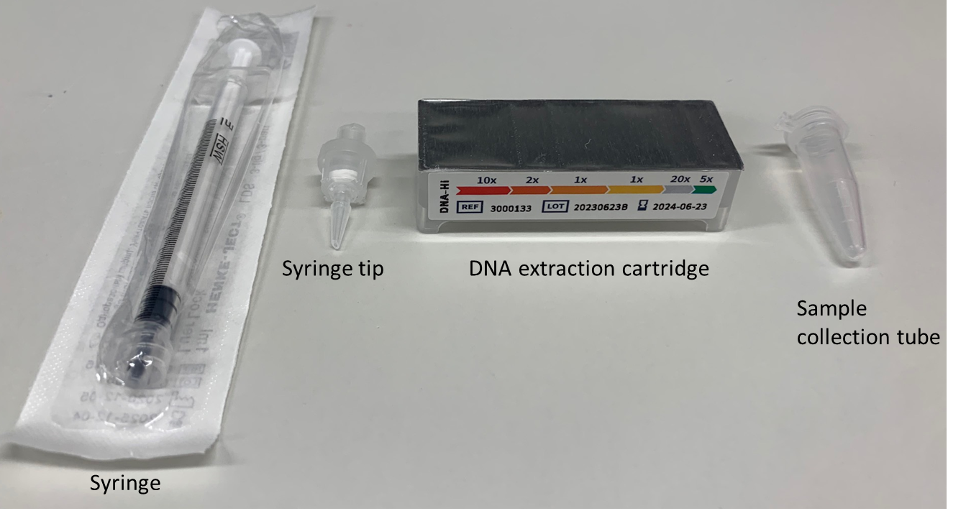

Setting up the PCR
- Tear open the foil pouch to retrieve the go-strips (make sure the dried reagents are at the bottom of the tube by tapping firmly on a solid surface.
- Remove the foil seal from the strip and using a 20 µl fixed volume pipette with a pipette tip on the end transfer the DNA sample into 1 well of the Go-strips per sample.
- To 1 well of the Go-strip add water as a contamination control. To a second well add a positive control sample to ensure the test is working as expected.
- Pipette up and down around 5x in each Go-Strip well to ensure the sample and lyophilized reagents are well-mixed.
- Once all the samples have been transferred and the void-filling caps have been placed in the Go-Strips, gently tap the Go-Strips on a nearby surface to make sure they are settled and there are no large bubbles at the bottom.
- Align the go strips and void filling caps so that the go-strip connections are visible through the cap cut-outs (see picture).
- Open the lid of the Franklin thermocycler and place the go-strips into the 3 well slots.
- Ensure the tubes are oriented correctly with the strip connection and gaps in the void filling caps at the back.
- Navigate to the Biomeme Go mobile application on the associated smartphone to begin your testing protocol by scanning the QR code on the tests foil pouch.
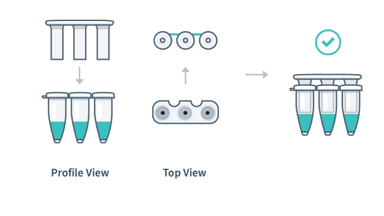

Running the PCR
- Confirm the test protocol displayed is correct.
- Select the number of go-strips you will be using (depending on the number of samples you have).
- Choose the run layout – i.e. 3 samples – 1 replicate each.
- Input sample IDs – these can be renamed as sample names or left as 1-3 if the information is recorded elsewhere.
- Select an appropriate folder to save the data in.
- At this point the run name can be recorded or changed as needed.
- Turn the thermocycler on by pressing the power button, connect the phone via the USB cable.
- Confirm the samples have been prepared and placed into the machine as requested.
- Close the lid and start the run.
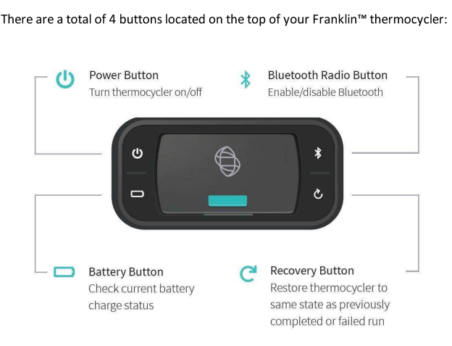
(See the Biomeme Franklin manual for more details)

Results interpretation
- After the run is complete, open the Biomeme go app and the results data will be transferred. The picture below shows an example of the results obtained after a run.
- The first results screen shows a summary of results. The results can be viewed for each 3 well go-strip. The green channel depicts whether the sample is positive for E. coli. The Amber channel can be ignored. The red channel is an internal positive control (IPC) and shows if the test is working as expected.
- From the first screen we can see that in wells 7-9, only well 9 is positive for E. coli, but all samples were +VE for the IPC. The Cq values given indicate the cycle in the PCR where the target could be detected out of the 40 cycles in the run.
- The second results screen shows the amplification curves for the samples – sometimes the software can misinterpret if samples are positive. Therefore, the second screen must always be checked to ensure samples have the expected amplification curve.
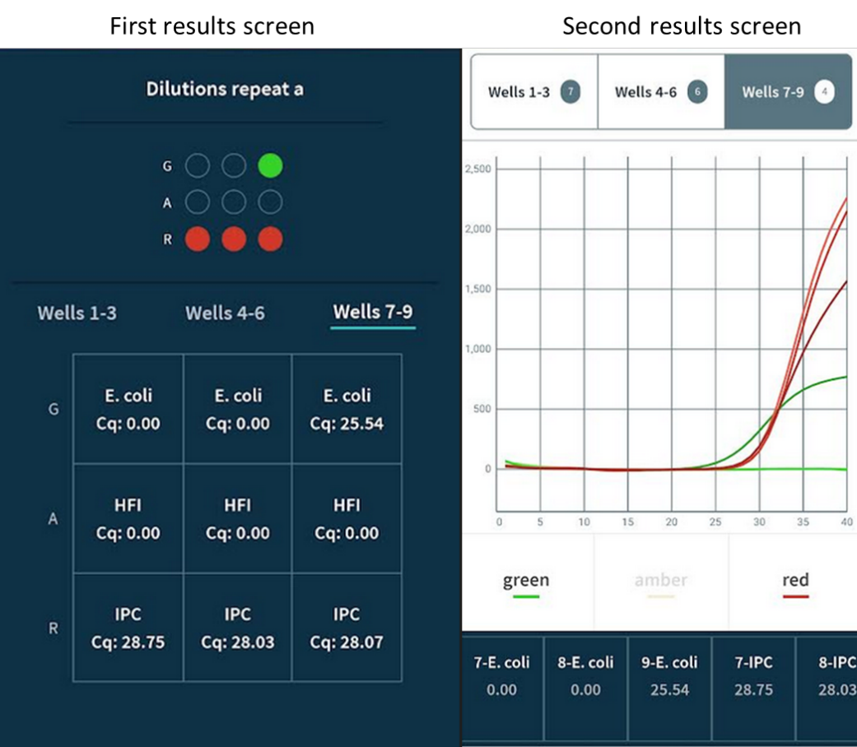
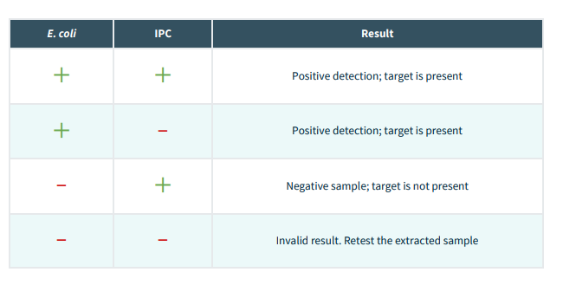

To watch these tips and a full sample prep, view the How-To Video: https://vimeo.com/374684460

