PATH-SAFE:
Rapid in-field diagnostic technologies for foodborne pathogens
Annex 4: Training instructions for detection of Salmonella in Sesame seeds using LAMP

NOTE: This document is a training aid for participants in the pilot study and is not intended to be used for testing without future revision to ensure consistent and safe implementation.
Checklist before starting the procedure
- Switch on the heat block. Press heat and make sure it is set at 95°C. Temperature can be changed by rotating the knob.
- Plug in the mini-centrifuge.
- Defrost LAMP reagents on the bench at room temperature for at least 30 minutes before setting up of the LAMP reaction.
Anti-contamination procedures
  - Clean the work bench area using 70% ethanol and tissue paper before starting the process.
  - Clean required pipettes (2-20 µl, 20-200 µl, 200-1000 µl) using 70% ethanol on tissue paper. Do not spray cleaning solution directly on the pipettes.
  - Only use one pipette tip per sample and change the tip in case of contact with any surface.
  - Do not ‘pop’ tubes open but open carefully using both hands, only open one sample lid at a time and close immediately after use. Keep the lids inverted on the surface.
  - Always briefly mix samples and controls before use. When handling sample tubes and controls, keep them physically separated from the LAMP reaction strip area.
  - Wear gloves throughout the testing process.

- Crude bacterial DNA extraction from Sesame seeds

Requirements: Seeds, Nalgene bottles, sterile water, cell strainer (100 um), Filter funnel, vacuum hand pump and tubing, forceps, 5ml tube with ball bearing, pipettes (2-20 µl, 20-200 µl, 200-1000 µl), filter tips (20 µl, 200 µl, 1000 µl) and 1.5ml tubes.

Sample Preparation
  - For each 200 gm sample, 5 subsamples were taken in Nalgene bottles. Fill each bottle with seeds till the marking provided (black line below the strip) so that the approximate seed quantity in each bottle is 25gm. Label sample ID on each bottle.

Filtration
  - Set up the filtration apparatus by attaching the vacuum hand pump to the disposable filter funnel via the clear plastic tubing. Caution: If plastic tubing does not fit on the funnel, dip the end of the tube in warm water for a few seconds and try again.
  - To dislodge bacterial cells from the surface of the seeds, add approximately 100 ml of sterile water (to the clearly marked red fill line indicated on the bottle) and manually shake the bottle for 10 - 15 seconds. Caution: Do not extend the shaking time, as excessive agitation may increase turbidity and make filtration more difficult..
  - The next step is to separate seeds and liquid. Remove the lid of the Nalgene bottle and add a cell strainer to the top, hold the cell strainer tight, and pour the water extract into the top part of the filter funnel. Change gloves after this step. Caution: if the cell strainer is not held tightly, seeds might flow out with liquid. In case this happens, manually remove the seeds from the filter unit using forceps.
  - Filter the sample by compressing the hand vacuum pump a few times (3-4) until the water starts to flow through. This step will concentrate bacterial cells onto the filter paper. Caution: for white seeds, the water could be more cloudy therefore, this step could take a little longer. It is important to quickly pump a few times as soon as water is added to the filter unit.
  - Once the sample is filtered remove the funnel section by rotating to expose the filter paper.
DNA Extraction
  - Prepare the 5ml tube by unscrewing the capped tube and setting the ball bearing in the inverted cap of the tube. Label all tubes with the relevant sample numbers.
  - Pick up the filter paper using forceps and carefully roll into a loose tube using your hands with the sample facing inwards and place the filter paper into a 5 ml collection tube. Spread and flatten the filter paper against the inside of the tube using forceps. Change gloves after this step.
  - Add the ball bearing to the centre and using a 1000µl pipette, add 500µL sterile water to the tube.
  - Close the cap and vigorously shake the tube for 1 minute to release bacterial cells from the filter paper into the water.
  - Prepare two 1.5 ml tubes and label them with the relevant sample numbers. Using a 1000µl pipette, transfer 250 µl of the water extract into the first 1.5 ml tube. Heat the sample at 95°C for 5 minutes on a heating block. This heating step lyses the bacterial cells, releasing DNA into the solution. Prepare two 1.5ml tubes. Label all tubes with sample numbers. Using a 1000µl transfer pipette, transfer 250µl water extract into the first 1.5ml tube. Heat the sample at 95°C for 5min on a heating block. The heating step will disrupt the bacterial cells to bring DNA into the solution.
  - Spin the samples on the spinner for a few seconds to ensure any particulate matter will settle at the bottom. Before starting the spinner, make sure that the tubes are balanced.
  - Using a 200µl pipette, separate 100µl of the upper clear solution into a second 1.5ml tube and label it. Caution: Do not disrupt the settled particulate matter, re-spin the tubes if required. After this step, the DNA extract can be saved for a day in the fridge (4°C) or for longer durations in the freezer (-20°C or -30°C).
  - In the case of black seeds, due to seed coloration, 1:5 dilution is required. Take a new 1.5ml tube, using a 20µl pipette, add 20µl of DNA from the previous step and using a 200µl pipette, add 80µl sterile water to make a total of 100µl dilution and label the tubes. Use this diluted DNA for LAMP. Diluted DNA can also be stored for a day in the fridge (4°C) or for longer durations in the freezer (-20°C or -30°C).
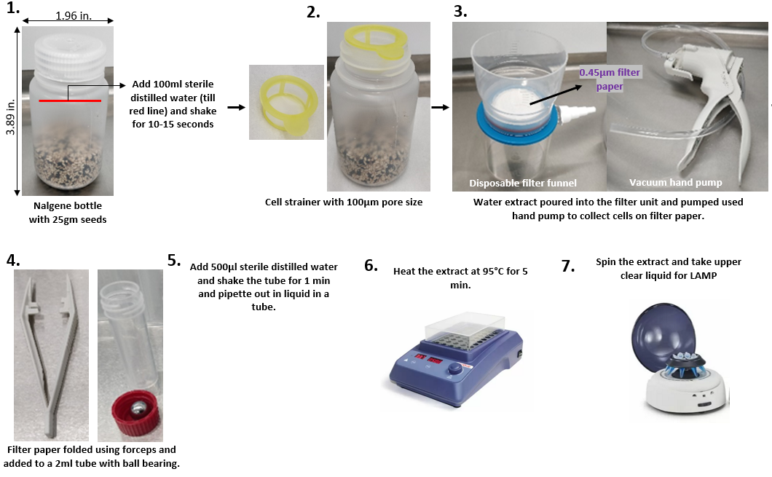
Figure 1: Pictorial representation of the crude extraction method.

2) LAMP reaction set-up:
  - Make sure all necessary reagents (ISO004 master mix, primer mix, BSA, positive and negative control) are defrosted and mixed briefly by tapping or shaking the tubes.
  - Add LAMP tube strip number on top ends. Do not write on the side of the tubes.
  - Prepare the master mix in a 1.5ml tube following the calculations in Table 1. Add all reagents towards the bottom of the tube. Using a 200µl pipette, first add 116µl of ISO004 master mix and then add 40µl of the primer mix. Next, using a 20µl pipette, add 4µl of BSA. Tap mix all reagents.

Table 1: LAMP reaction mixture preparation.

Reagent | Total volume (µl) for 8 reactions (8x)
Isothermal Master Mix (ISO-004) | 116
Salmonella Primer Mix | 40
BSA | 4

  - Using a 20µl pipette, add 20µl of the reaction mix in each well of the LAMP strip. While pipetting at steps 2.4 and 2.5 care should be taken not to introduce any bubbles as it can interfere with the results. Caution: While pushing the liquid out of the pipette, press the pipette knob gently till the first stopping point.
  - Arrange the controls and DNA sample tubes on a rack as per Figure 2. Using a 20µl pipette, add 5µl negative control to the first well, followed by 5µl DNA sample in wells 2-6. Close the lids of well 1-6. At last add 5 µl positive control in well 7. Close each well lid tightly.
  - If a bubble is observed in the wells, gently flick at the bottom of the tube. Tap the strip to make sure the reaction mix is at the bottom of each well, not on the sides. 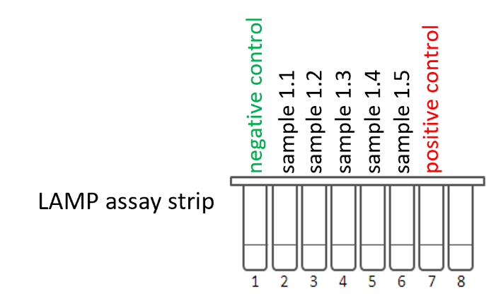
Figure 2: Layout of LAMP reaction strips.

3) Running the Genie II

  - Switch on the machine using the power button. After 2-3 seconds, a green light will appear on the front. Tap the screen to look at the contents. Make sure it has sufficient battery. If not, put it on charging.
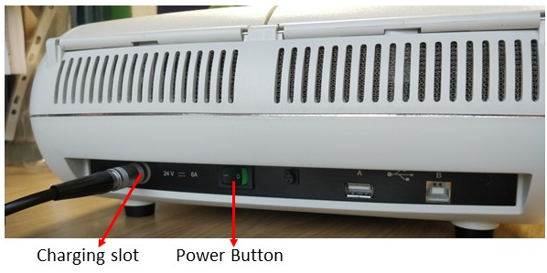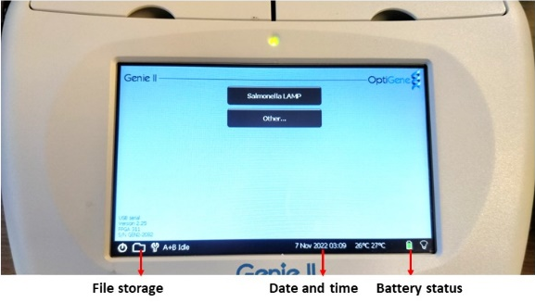
3.2 Put the strip in slot A, ensuring the correct orientation and close the lid. Slot B is not required for the current assay therefore, keep it closed.
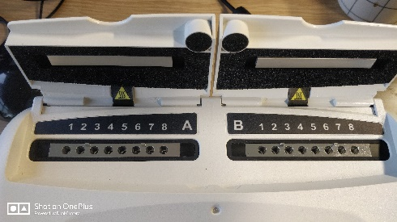
3.3 Select the profile named ‘Salmonella LAMP’ and click on block A.
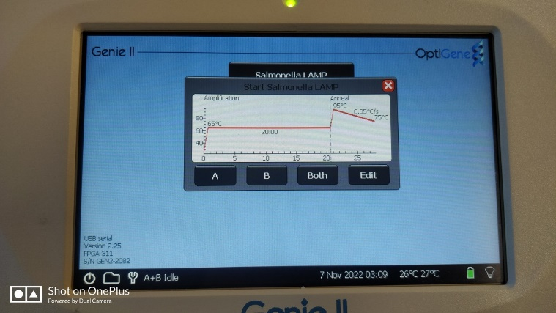
3.4 Record the Genie machine number and the run file number on the LAMP plan for each test performed. Result files are saved in the machine and this record allows accessing the result file later as shown in the figure.
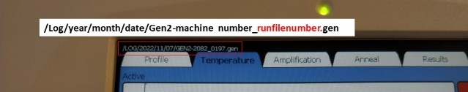

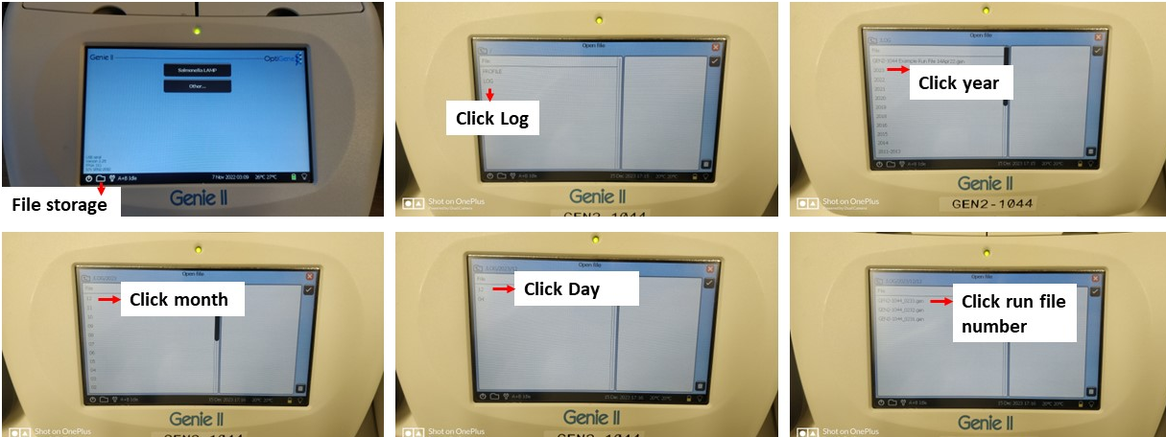

3.5 Total run time is approximately 30-40 minutes. Once the run is finished, remove Genie strips from the instrument only when it is cool and dispose them immediately, do not open the Genie strips.

4) Result interpretation
4.1 Always check both amplification and annealing graphs for reliable results.
4.2 No increase in amplification and annealing peak should be observed for negative control.
4.3 Positive control should have a clear s-shaped amplification curve and the annealing peak should be at 87.5 °C (±1°C) for this Salmonella assay.
4.4 A sample is considered positive or infected with Salmonella if it shows amplification in the graph and annealing at the right temperature and the result window shows clear readings.
